Exp1: Android Studio Installation and figma design of application
Aim:
To install android studio and setup the environment. To complete figma designs for the individual and team project.

Screenshots:

Individual Project (Placement Prep App):

- Home Page:

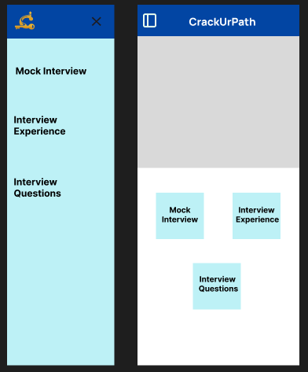

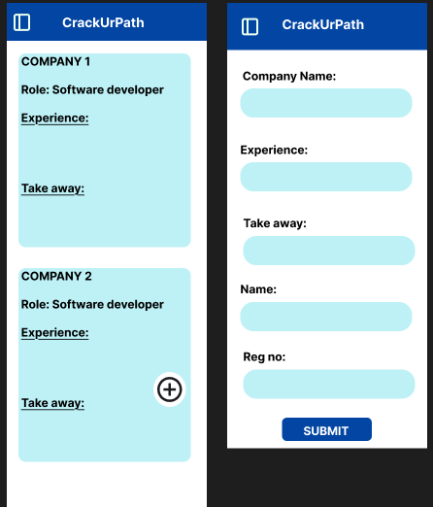
- Interview Experience

- Mock Interview Page

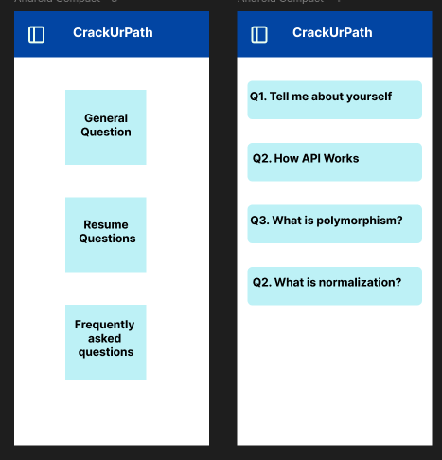
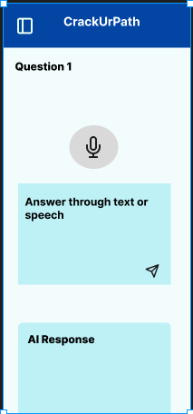

Team Project (TCE Material Base):

- Login and Home page
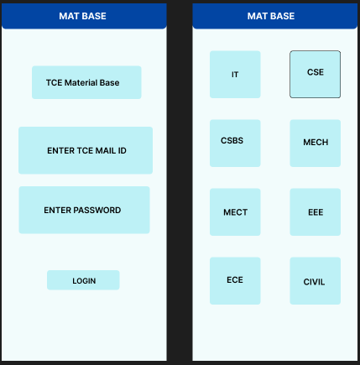
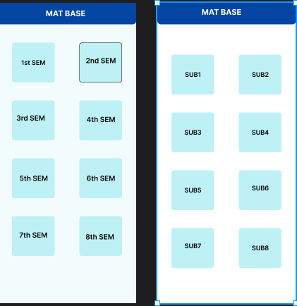
- Module wise materials and grade calculator
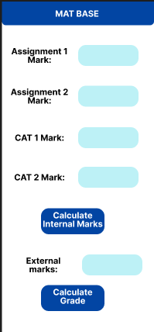
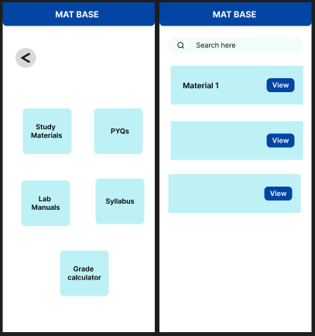

Android Studio Installation and setup:

